MOTOR VEHICLE THEFT ANALYSIS IN NEWZEALAND (2021-2022)

Power BI Project Documentation
- Project Overview and Objective
The “Motor Vehicle Theft Analysis – New Zealand (2021–2022)” project was developed using Microsoft Power BI to analyze vehicle theft patterns and trends across different regions, vehicle categories, and time periods. The dashboard transforms raw theft data into meaningful visual insights that help understand theft distribution, high-risk areas, and commonly stolen vehicle types.
The main purpose of this project is to identify patterns in vehicle theft incidents and provide an interactive dashboard for data-driven decision-making. The dashboard enables users to explore theft data dynamically through charts, slicers, KPIs, and maps.
The project focuses on:
- Understanding overall theft trends
- Identifying high-risk regions
- Finding the most stolen vehicle types
- Analyzing monthly and yearly theft patterns
- Creating interactive reports using Power BI visualizations
- Data Sources
Source Description: https://mavenanalytics.io/data-playground/motor- vehicle-thefts

Data Set Information
Date Domain: Crime Analytics – Motor Vehicle Theft Analysis for Police Department
Data Period: 2021- 2022
Data Source Type: CSV / Excel File, Imported into Power BI for analysis

- Objectives

- Analyze Overall Vehicle Theft Trends
To analyze the total number of vehicle thefts over different periods such as year, month to identify theft trends and patterns
- Identify the Most Stolen Vehicle Types
To find which vehicle types are stolen the most and compare theft counts among different vehicle categories.
- Determine High-Risk Theft Locations
To identify regions or cities with the highest number of vehicle thefts and understand location-based crime distribution.
- Analyze Theft Patterns by Time
To study theft occurrences by month, weekday, or season to identify peak theft periods.
- Compare Vehicle Brands and Models Involved in Theft
To analyze which vehicle makes or brands are more frequently targeted by thieves.

- Attribute (Column /Features) Details:
Field | Data Type | Description
Vehicle_id | Whole Number | Unique ID of a stolen vehicle
Vehicle_type | Text | Type of vehicle
Make_id | Whole Number | Matches make_id in the make_details table
Model_year | Whole Number | Model year of vehicle
Vehicle_desc | Text | Description of vehicle
Color | Text | Color of vehicle
Date_stolen | Date | Date the vehicle was stolen (MM/DD/YY)
Location_id | Whole Number | Matches location_id in the locations table
Make_id | Whole Number | Unique ID of the make
Make_name | Text | Name of the make
Make_type | Text | Type of make (Standard or Luxury)
Location_id | Whole Number | Unique ID of the region
Region | Text | Name of the region
Country | Text | Country where the region is located
Population | Whole Number | Population of the region
Density | Decimal Number | Density of the region (population / km2)

5. Tools & Technologies Used:
- Microsoft Power BI
- Power Query Editor
- DAX (Data Analysis Expressions)
- Data Cleaning & Transformation (Power BI-Power query)
- Data Modelling
- Data Visualization
- KPI Dashboard Design
- Crime Data Analytics

6. Data Pre-Processing (Power BI-Power Query)
The raw dataset was cleaned and transformed before visualization. Data pre-processing was performed using Power Query Editor in Power BI.

Tasks Performed
Data Cleaning
- Handled missing/null values by deleting incomplete rows improve data accuracy and consistency.
- Corrected inconsistent data formats
- Renamed column headers for readability
- Changed data types appropriately

Data Transformation
    - Extracted Month and Year from theft date
    - Created Month Name column
    - Created Month Number column for sorting
    - Created Month Year Sort for Year sorting
    - Categorized vehicle age groups
    - Standardized region and vehicle category names
Data Preparation
    - Created Calendar Table
    - Sorted Month & Year names chronologically
    - Built relationships between tables
    - Added calculated columns and measures

7. Data Modelling and DAX (Power BI)
Data modeling was implemented in Power BI to establish relationships between tables and improve report performance
Data Modelling
The project follows a relational model where the vehicle theft data acts as the main fact table connected with supporting dimension tables such as Calendar, Location and Make Details.
Relationships Used
- Cardinality: Many-To-One Relationships
- Calendar Table Relationships
- Region-based Relationships

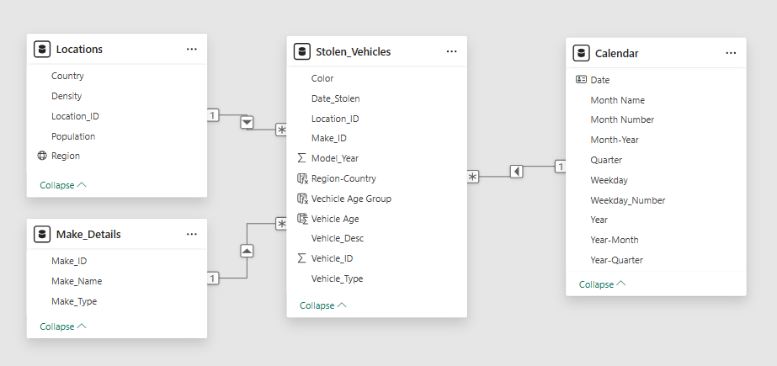

DAX Measures Created
Measure Name | Purpose
Total Population | Calculates overall population
Total Vehicle Theft | Calculates total theft incidents
Peak Theft Month | Identifies the month with highest theft in 2022
Theft Difference | Compares theft counts between periods
Theft Risk Category | Categorizes theft levels into Low, Medium, High
Vehicle Age Group | Groups vehicles based on age

8. Analysis and Visualizations (Power BI)
The Power BI dashboard was designed with interactive visuals to analyze theft trends and patterns effectively.

Dashboard Features

KPI Cards
Used to display:
- Total Population
- Total Vehicle Theft
- Yearly Theft Comparison
- Peak Theft Month
- High-Risk Region
- Most Theft Vehicle Type
- Total Vehicle Categories

Line Chart

Purpose:
    - Analyze monthly and yearly theft trends
    - Identify seasonal theft patterns

Column Chart

Purpose:
- Compare theft counts across regions and vehicle categories

Donut Chart

Purpose:
- Show theft distribution by vehicle color or category
- Analyze percentage contribution

Tree map

Purpose:
- Visualize theft contribution by vehicle category or region

Table / Matrix Visual

Purpose:
- Display detailed theft records and find Theft risk Categories by Vehicle type and their counts
- Compare multiple attributes (Vehicle type & Make name) simultaneously

Interactive Report Features

Slicers Used
- Year Slicer
- Month Slicer
- Region Slicer
- Vehicle Type Slicer

SCREENSHOT OF DASHBOARD

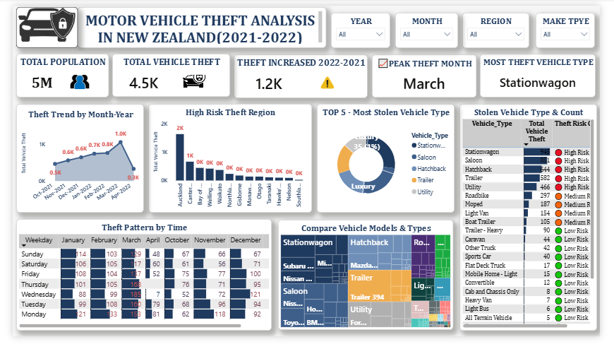

9. Insights

Key Findings
- Vehicle theft incidents showed variation across months during 2021–2022.
- Certain regions recorded significantly higher theft counts compared to others.
- Station wagons recorded the highest number of theft incidents in 2022.
- Theft frequency increased during selected peak months.
- Some large amount of standard - vehicle type more frequently in theft records.
- Theft distribution was uneven across different locations.
- Interactive filtering helped identify region-specific theft patterns.

10. Theft Trend by Month -Year Analysis (Oct 2021 – Apr 2022)

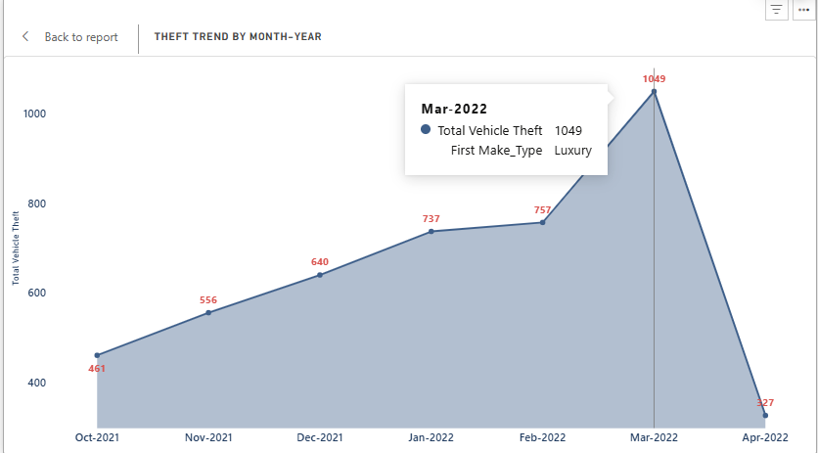

1. Descriptive Analysis (What Happened?)
- Luxury vehicle thefts showed a continuous increase from 461 thefts in Oct-21 to 1049 thefts in Mar-22.
- The highest theft count was recorded in March 2022 (1049 thefts) and Theft cases dropped sharply to 327 thefts in Apr-22 after the March peak.
- Overall trend indicates that luxury vehicles became increasingly targeted during late 2021 and early 2022.
- Diagnostic Analysis (Why Did It Happen?)
The steady increase may indicate:
- Higher demand for luxury vehicle parts in illegal markets.
- Increased criminal targeting of high-value vehicles.
- Possible weaknesses in vehicle security systems or parking safety.
- The sudden spike in Mar-22 suggests:
Seasonal crime increases:
- Organized theft activities,
- Or reduced law enforcement monitoring during that period.
- The decline in Apr-22 have occurred due to the 6 days of Theft Data from Crime Department.

- Predictive Analysis (What Might Happen Next?)
- Luxury vehicle thefts may continue to increase if current trends persist.
- Certain months could continue to show higher vehicle theft activity.
- Premium and high-value vehicles are likely to remain major theft targets.
- Urban and densely populated regions may face higher future theft risks.

- Prescriptive Analysis (What Should Be Done?)
- Install GPS trackers and anti-theft systems in vehicles to reduce theft risk.
- Increase police patrols and CCTV surveillance in high-theft regions.
- Encourage the use of secure parking areas, especially for luxury vehicles.
- Monitor theft trends regularly to identify future high-risk periods and locations.

11. Regional Vehicle Theft Analysis – New Zealand

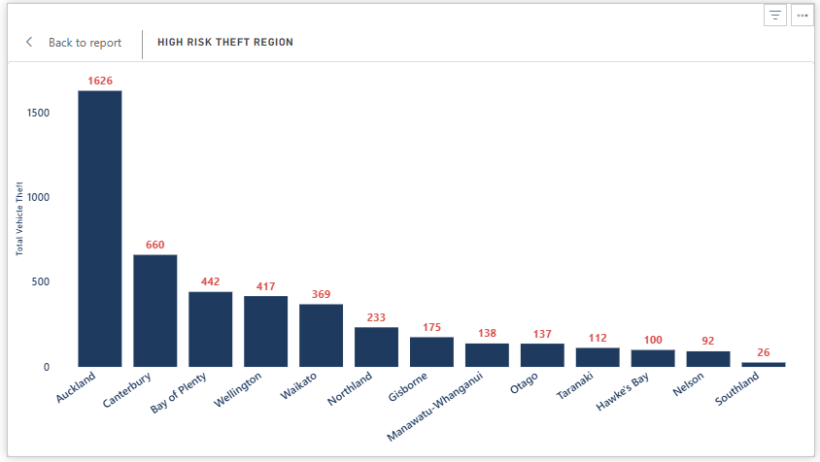
- Descriptive Analysis (What Happened?)
- Auckland recorded the highest vehicle theft count with 1,626 cases, making it the most affected region.
- Canterbury reported the second-highest theft count with 660 cases, followed by Bay of Plenty and Wellington.
- Regions with larger populations generally showed higher vehicle theft incidents.
- Waikato and Northland experienced moderate theft activity compared to highly urbanized regions.
- Southland had the lowest theft count with only 26 cases, indicating comparatively lower theft risk.

- Diagnostic Analysis (Why Did It Happen?)
- Highly populated urban regions likely faced more thefts due to increased vehicle ownership and traffic density.
- Busy commercial areas and public parking spaces may have created more opportunities for vehicle theft.
- Auckland’s significantly high theft level may indicate stronger criminal activity or organized theft networks.
- Smaller regions such as Southland and Nelson may experience fewer thefts because of lower population density and reduced vehicle concentration.
- Economic activity and tourism in certain regions could also contribute to higher vehicle theft occurrences.

- Predictive Analysis (What Might Happen Next?)
- Auckland is likely to continue experiencing the highest vehicle theft risk if current trends remain unchanged.
- Rapid urban growth in regions like Wellington and Waikato may increase future theft incidents.
- High-population and high-traffic regions may continue to become major theft hotspots.
- Smaller regions with currently low theft levels could see gradual increases as vehicle ownership grows.
- Seasonal or economic changes may further influence future theft patterns across regions.

- Prescriptive Analysis (What Should Be Done?)
- Authorities should increase CCTV surveillance and police patrols in high-theft regions such as Auckland and Canterbury.
- Vehicle owners should use anti-theft devices, GPS tracking systems, and secure parking facilities.
- Public awareness campaigns can educate citizens about vehicle safety and theft prevention measures.
- Data monitoring systems should be implemented to identify emerging theft hotspots quickly.
- Regional law enforcement agencies should focus on predictive policing and targeted crime prevention strategies.

12. Top 5 – Most Stolen Vehicle Type analysis

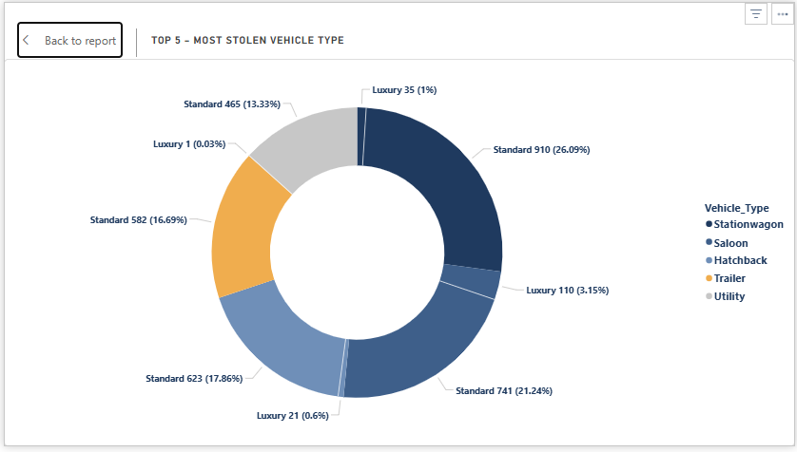

1. Descriptive Analysis
- Standard vehicles experienced significantly higher theft counts compared to luxury vehicles.
- Station wagons were the most stolen vehicle type with 910 theft cases.
- Saloons and hatchbacks also showed high theft frequencies among standard vehicles.
- Trailer and utility vehicles recorded moderate theft activity.
- Luxury vehicle thefts were comparatively lower, with luxury saloons being the most targeted.

2. Diagnostic Analysis
- Standard vehicles may be stolen more frequently because they are widely used and easily accessible.
- High-demand spare parts for station wagons and saloons could contribute to increased thefts.
- Common vehicle models are often easier to resell in illegal markets.
- Luxury vehicles may have advanced security systems, reducing theft opportunities.
- Utility and trailer thefts may occur due to weaker parking security in commercial areas.

3. Predictive Analysis
- Standard vehicles are likely to remain the primary target for vehicle thefts.
- Station wagons and saloons may continue showing high theft rates in future periods.
- Theft risks could increase further in urban and high-traffic regions.
- Luxury vehicle thefts may slowly rise if criminals target high-value vehicles.
- Vehicle types with weak security features may continue facing higher theft risk.

4. Prescriptive Analysis
- Authorities should increase surveillance in areas with high standard vehicle theft rates.
- Public awareness programs can help owners improve vehicle safety practices.
- Manufacturers can enhance security technologies in commonly stolen vehicle types.
- Regular monitoring of theft trends can support faster crime prevention measures.

13. Top 5 – Most Stolen Vehicle Type analysis
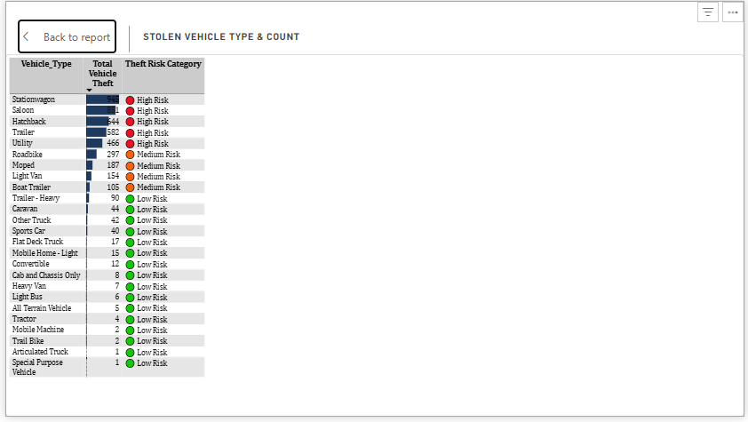

Descriptive Analysis
- Standard vehicles experienced significantly higher theft counts compared to luxury vehicles.
- Station wagons were the most stolen vehicle type with 910 theft cases.
- Saloons and hatchbacks also showed high theft frequencies among standard vehicles.
- Trailer and utility vehicles recorded moderate theft activity.
- Luxury vehicle thefts were comparatively lower, with luxury saloons being the most targeted.

Diagnostic Analysis
- Standard vehicles may be stolen more frequently because they are widely used and easily accessible.
- High-demand spare parts for station wagons and saloons could contribute to increased thefts.
- Common vehicle models are often easier to resell in illegal markets.
- Luxury vehicles may have advanced security systems, reducing theft opportunities.
- Utility and trailer thefts may occur due to weaker parking security in commercial areas.

Predictive Analysis
- Standard vehicles are likely to remain the primary target for vehicle thefts.
- Station wagons and saloons may continue showing high theft rates in future periods.
- Theft risks could increase further in urban and high-traffic regions.
- Luxury vehicle thefts may slowly rise if criminals target high-value vehicles.
- Vehicle types with weak security features may continue facing higher theft risk.

Prescriptive Analysis
- Vehicle owners should install GPS trackers and anti-theft security systems.
- Authorities should increase surveillance in areas with high standard vehicle theft rates.
- Public awareness programs can help owners improve vehicle safety practices.
- Manufacturers can enhance security technologies in commonly stolen vehicle types.
- Regular monitoring of theft trends can support faster crime prevention measures

14. Top 5 – Most Stolen Vehicle Type analysis

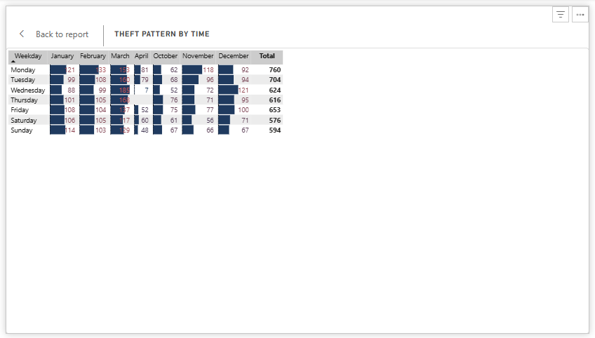

Descriptive Analysis
- Vehicle thefts were highest during March across almost all weekdays.
- Wednesday and Thursday in March recorded the highest theft counts.
- Monday and Tuesday also showed consistently high theft activity.
- Theft cases were comparatively lower during October and November.
- April showed a noticeable decline in theft incidents across all weekdays.

Diagnostic Analysis
- Increased movement and public activity in March may have created more theft opportunities.
- Midweek days like Wednesday and Thursday may have higher traffic and parking congestion.
- Criminals may target busy weekdays when vehicle monitoring is lower.
- Lower thefts in April could indicate improved security or reduced criminal activity.
- Seasonal and social patterns may influence vehicle theft occurrences.

Predictive Analysis
- March may continue to remain a high-risk month for vehicle thefts.
- Midweek days are likely to experience higher theft activity in future periods.
- If preventive measures are not improved, theft patterns may remain consistent.
- Urban and crowded areas may continue facing higher weekday theft risks.
- Future theft spikes may occur during busy travel or work periods.

Prescriptive Analysis
- Authorities should increase patrols during high-risk weekdays and months.
- Vehicle owners should avoid parking in isolated or unsecured areas.
- CCTV monitoring should be strengthened in busy parking locations.
- Public awareness campaigns can help reduce vehicle theft risks.
- Data monitoring should be used to identify and prevent future theft hotspots.

15. Compare Vehicle Models and Types

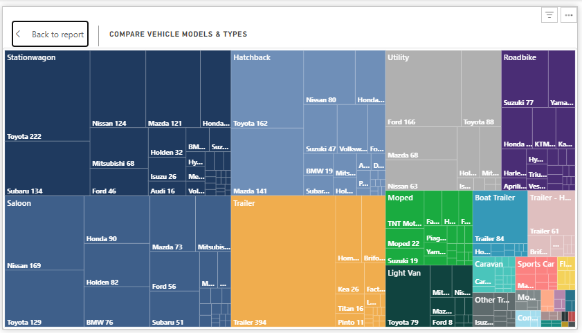

Descriptive Analysis
- Station wagon, Saloon, Hatchback, and Trailer vehicles recorded the highest theft counts.
- Toyota, Nissan, Mazda, Ford, and Subaru were the most frequently stolen vehicle brands.
- Standard passenger vehicles were stolen more often than luxury or special-purpose vehicles.
- Trailer and utility vehicles also showed considerable theft activity across multiple brands.

Diagnostic Analysis
- Common vehicle brands may be targeted more because they are widely available and easier to resell.
- High-demand spare parts for Toyota, Nissan, and Mazda could increase theft rates.
- Frequently parked public and unsecured vehicles may create more theft opportunities.
- Standard vehicles likely faced higher theft risk due to weaker security systems and higher usage.

Predictive Analysis
- Toyota, Nissan, and Station wagon vehicles may continue to face high theft risk in the future.
- Urban regions with high vehicle density may experience increasing theft incidents.
- Commonly used passenger vehicles are likely to remain the primary target category.
- Trailer and utility vehicle thefts may rise if security measures are not improved.

Prescriptive Analysis
- Vehicle owners should install GPS trackers and advanced anti-theft devices.
- Authorities should strengthen surveillance in high-risk parking and urban areas.
- Public awareness programs can encourage safer parking and vehicle protection practices.
- Regular theft trend analysis can help identify future high-risk vehicle categories and brands.

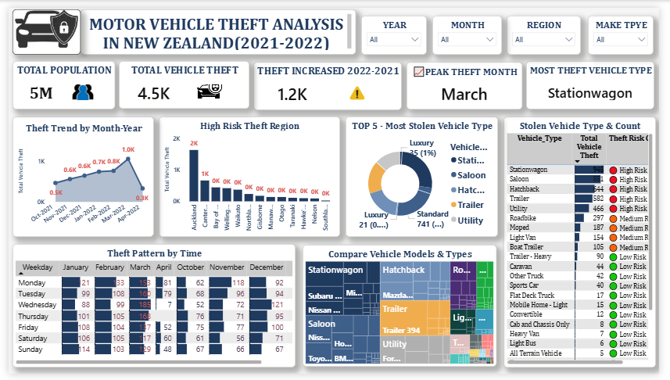

16. Conclusions
- The Motor Vehicle Theft Analysis dashboard successfully transformed raw theft data into meaningful and interactive visual insights using Power BI. The project helped identify theft trends, risky regions, commonly stolen vehicle types, and monthly theft variations.
- The use of Power Query, DAX measures, data modeling, and interactive visualizations improved analytical understanding and reporting capabilities. The dashboard enables users to filter and explore theft data dynamically, making the report more informative and user-friendly.
- Overall, this project demonstrates the effective use of Power BI for crime data analysis and business intelligence reporting while enhancing data visualization and analytical skills.

